Team Bravo: Milestone #2

Andrew Bach, Torren Davis, John Garcia III, Taylor Mommer & Ian Spresney

Bellevue University

CSD 310: Database and Development Use, Assignment #: 10.1

Professor Sue Sampson

December 3rd, 2023

**Team Bravo: Milestone #2**

**Revised ERD:**

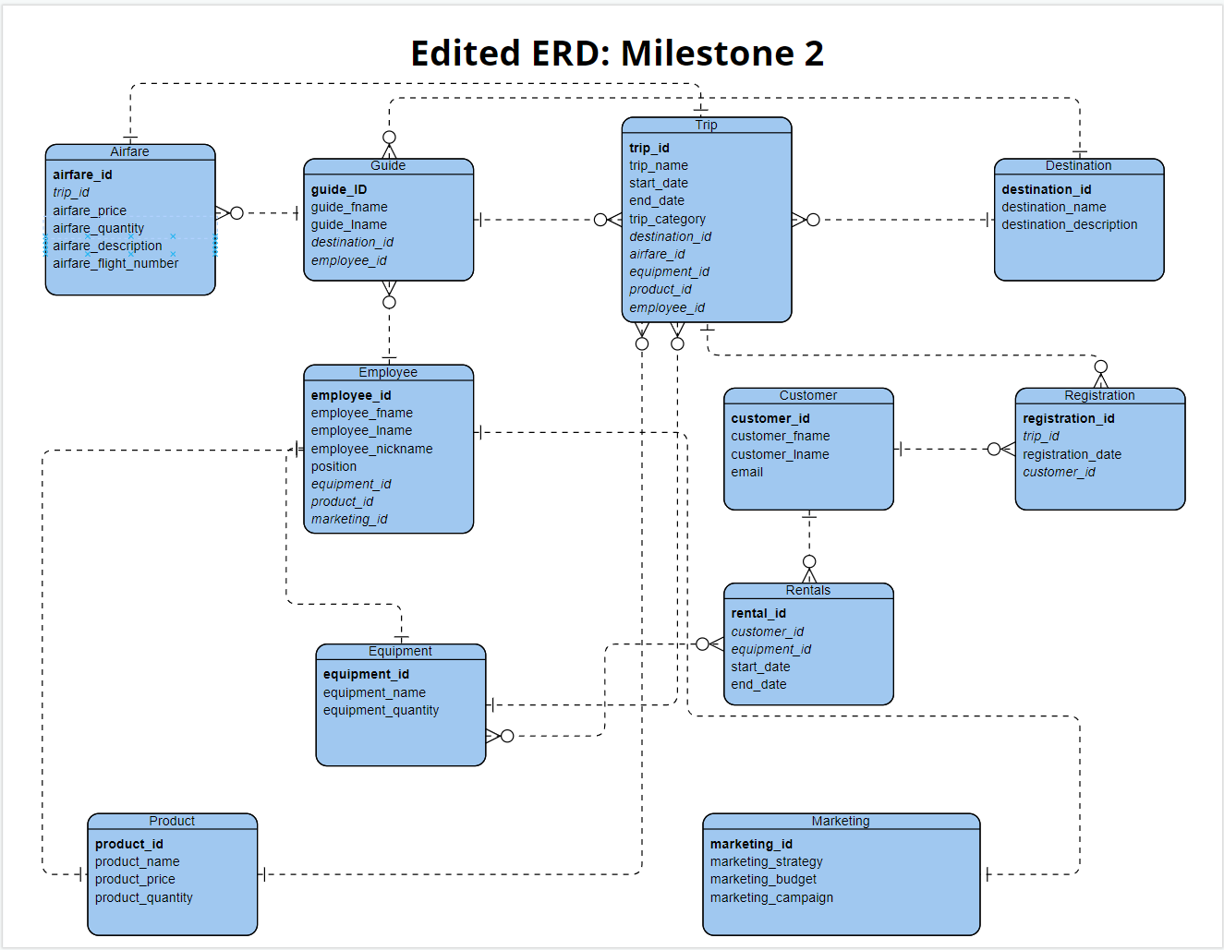

**Screenshots of Data from Scripts:**

